Ethan Crawford

CSS 422

January 22, 2009

Homework Problem Set #2

From <https://faculty.washington.edu/aberger/CSS422W09/Homework/Homework%202/CSS422W09HW2.htm>

1. Assume a logic circuit that has, as its inputs, two 4-bit binary numbers (A0 through A3 and B0 through B3) and, as its output, a single binary output, Z. The output Z is TRUE (HIGH) if the two numbers are equal. Design the circuit that implements this equality tester.

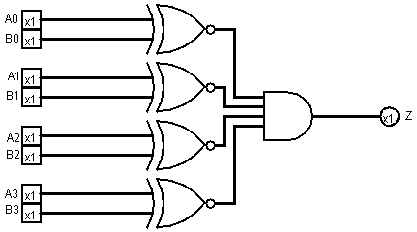

1. Complete the truth table for the following sequential circuit:

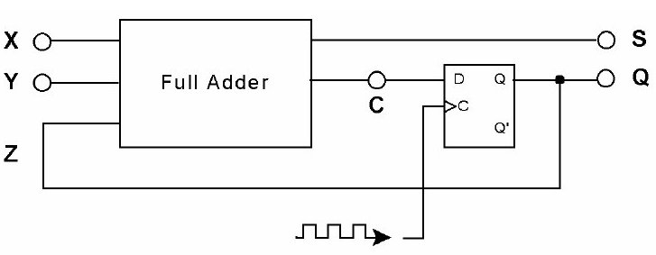

|  |  |  |  |  |  |  |  |  |
| --- | --- | --- | --- | --- | --- | --- | --- | --- |
|  | | | clk 0 | | | clk 1 | | |
| X | Y | Z | S | C | Q | S | C | Q |
| 0 | 0 | 0 | 0 | 0 | 0 | 0 | 0 | 0 |
| 0 | 0 | 1 | 1 | 0 | 0 | 1 | 0 | 0 |
| 0 | 1 | 0 | 1 | 0 | 0 | 1 | 0 | 0 |
| 0 | 1 | 1 | 0 | 1 | 0 | 0 | 1 | 1 |
| 1 | 0 | 0 | 1 | 0 | 0 | 1 | 0 | 0 |
| 1 | 0 | 1 | 0 | 1 | 0 | 0 | 1 | 1 |
| 1 | 1 | 0 | 0 | 1 | 0 | 0 | 1 | 1 |
| 1 | 1 | 1 | 1 | 1 | 0 | 1 | 1 | 1 |

1. Design a state machine circuit that will detect the occurrence of the serial bit pattern 1001.

Truth table: call occurrence detection bit 'S'.

|  |  |  |  |  |  |
| --- | --- | --- | --- | --- | --- |
| Ain | Bin | in | Aout | Bout | out |
| 0 | 0 | 0 | 0 | 0 | 0 |
| 0 | 1 | 0 | 1 | 0 | 0 |
| 1 | 0 | 0 | 1 | 1 | 0 |
| 1 | 1 | 0 | 0 | 0 | 0 |
| 0 | 0 | 1 | 0 | 1 | 0 |
| 0 | 1 | 1 | 0 | 0 | 0 |
| 1 | 0 | 1 | 0 | 0 | 0 |
| 1 | 1 | 1 | 0 | 0 | 1 |

K-map reduction:

Aout = 'in(A xor B)

|  |  |  |  |  |
| --- | --- | --- | --- | --- |
| AB/in | 00 | 01 | 10 | 11 |
| 0 |  | 1 | 1 |  |
| 1 |  |  |  |  |

Bout = 'B(A xor in)

|  |  |  |  |  |
| --- | --- | --- | --- | --- |
| AB/in | 00 | 01 | 10 | 11 |
| 0 |  |  | 1 |  |
| 1 | 1 |  |  |  |

out = ABin

|  |  |  |  |  |
| --- | --- | --- | --- | --- |
| AB/in | 00 | 01 | 10 | 11 |
| 0 |  |  |  |  |
| 1 |  |  |  | 1 |

Equations:

Aout = 'in(A xor B)

Bout = 'B(A xor in)

out = ABin

State machine circuit:

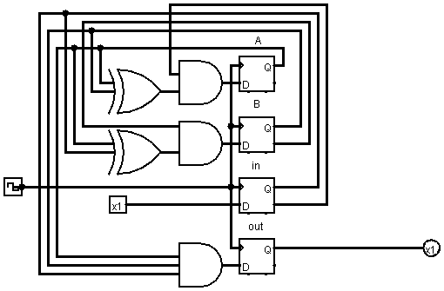

4- Extra credit: What are the names of the cute little robots in the Sci-Fi Movie, "Silent Running"? Huey, Dewey, and Louie.